PRESS RELEASE

No. 53/SP/TKP-ASEAN2023/04/2023

PUBLIC COMMUNICATIONS TEAM

As ASEAN Chair, Indonesia Continues to Bridge Differences in Myanmar

Jakarta, Kominfo Newsroom – Indonesia's Foreign Affairs Minister Retno Marsudi said that Indonesia, as the ASEAN chair, continued to bridge differences in views and positions in Myanmar.

"We (Indonesia) as the chair (of ASEAN) open engagement (two-way communications) as wide as possible to listen to their thoughts and bridge differences," said Minister Retno on Indonesia's ASEAN Chairmanship contribution toward the Myanmar conflict resolution.

This was conveyed by Minister Retno after attending a limited meeting with President Joko Widodo to discuss ASEAN Summit preparations at the Presidential Palace in Jakarta, Thursday, 27 April.

She said the conflict in Myanmar is not easy, but Indonesia as the ASEAN chair will build communications.

She revealed that in ASEAN Chairmanship, Indonesia established communication between the Myanmar military and the National Unity Government of Myanmar (NUG), Ethnic Armed Groups, and several political parties.

Following the previous summit decision, Retno said Myanmar will be invited to the 2023 ASEAN Summit at the non-political representative level because of the ongoing conflict in the country.

She also said there would be two meeting sessions at the ASEAN Summit: a plenary and a retreat.

There will be discussions on the implementation of the Five-Point Consensus on Myanmar in the retreat session.

The Five-Point Consensus is the decision of ASEAN leaders through a special meeting attended by Myanmar's junta leader General Min Aung Hlaing to help Myanmar to overcome its political crisis.

The Five-Point Consensus calls for an end to violence; a dialogue of all stakeholders; the appointment of a special envoy to facilitate mediation and dialogue; permission for ASEAN to provide humanitarian assistance to the people of Myanmar; and permission for ASEAN special envoy to visit and meet with parties in Myanmar.

Minister Retno said ASEAN leaders will review the Five-point Consensus at the retreat session.

She underscored that by President Joko Widodo's directives, this year's ASEAN Summit will discuss the Myanmar issue, but ASEAN priorities remain on the acceleration of ASEAN Community development whose benefits are always asked by the ASEAN people.

"What are the benefits of ASEAN matters for the people? This is what ASEAN leaders must answer," Retno said.

The ASEAN Summit will be held in Labuan Bajo, East Nusa Tenggara, on 10--11 May. The government has made various preparations at the event venues.

Previously, President Joko Widodo had checked the venues for the ASEAN Summit. According to Minister Retno, all ASEAN Summit preparations are on the right track. (Ranga/TR/Elvira)

***

For more information, please contact:

Director General of Public Information and Communications of the Ministry of Communications and Informatics - Usman Kansong (0816785320)

Get other information at https://infopublik.id

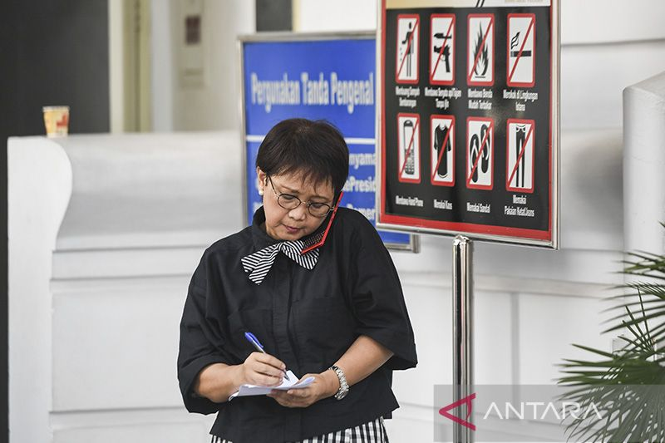

Foreign Minister Retno Marsudi is seen at the Presidential Palace complex in Jakarta after attending a limited meeting (ratas) led by President Joko Widodo, Thursday, 27 April 2023. ANTARA FOTO/Hafidz Mubarak A/tom/aa.

